STEP ONE- Nurse or GP

Case Finding
COPD Suggested see separate guideline
Asthma suspected from symptoms

New-patient registration
Hospital Discharge
Initial Investigations

- Serial peak flows
- Reversibility tests
- Spirometry
- CXR
Criteria for Asthma- Code

STEP TWO- Nurse or GP
Initial Treatment

Prescribe medication according to severity
Identify and teach appropriate delivery system
Peak flow meter and card- if not already given (steroid card?)
Educate patient- give leaflet / pack
Initial Assessment

- History- triggers, symptoms
- Past Medical History/ atopic hx
- Drugs (Bblockers, Nsaids etc)
- Allergies and atopies
- Occupation
- Smoking history
- Level of fitness
- Examination- Height Weight and Peak flow

STEP THREE- Nurse or GP
First Follow-up Appointment at 2 weeks

- Review peak flow record, treatment frequency and response and compliance
- Review inhaler technique
- Assess patients understanding / ability to self-manage asthma
- Develop written management plan
- Educate re: warning signs etc.
- Adjust treatment accordingly

STEP FOUR – Nurse or GP Determine ‘Step’ for treatment and followup (page 10)

CASE FINDING AND INITIAL INVESTIGATIONS

- “Correct diagnosis of the condition is essential” (BTS Guidelines 1997). The key to this is demonstrating a variable nature of airway narrowing. The standard accepted way to do this is to monitor peak flow for 2 weeks whilst the patient is on high dose steroids. Not always practical.
- National levels of diagnosis ~ 15% children and 7% adults.
- Dangers- 1. Delayed / over-diagnosis in children. Mean age of diagnosis falling (6.7 in 1982 3.4 in 1987). Increasing prevalence of asthma in children. Atypical presentations (‘tingly back’, recurrent vomiting, chest pain, prodromal itching, behavioural changes). Delayed diagnosis (due to incorrect labeling- ‘wheezy bronchitis’, failure to appreciate significance of recurrent cough. Diagnosis difficult under ‘5’- different pathophysiology to chronic inflammation. Small airways proportional to r↑4, compliant chest wall- collapses in inspiration/expiration (air trapping), immunoinexperience, and increased effect of environment- smoking, viral responsiveness, and damp/mould.
- Dangers- 2. Under-diagnosis in elderly. Due to wider differential, difficulty with peak flow measurement, under reporting due to reduced expectations, breathlessness attributed to old age, COPD crossover. Anticholinergic bronchodilators may have more role in this age group.

Diagnosis
A clear history of wheezing, cough and breathlessness (for at least 6 weeks for children under 6 years), with either………

Improvement of peak flow of at least 15% after a course of high dose oral steroids-

30-60mg daily in adults- 2weeks (review after 1 week and switch to inhaled steroids if side effects and thus far inconclusive)

0.5 to 2mg per kg/day in children- for 1 week (but no more than 40mg/day)

……..or (If Age>/= 3)

Diurnal variation of reduced peak flow demonstrated whereby the lowest morning- peak flow shows at least a 15% fall compared to the highest evening value.
Highest-lowest × 100%
Highest
Or on basis of symptoms- exercise induced wheeze, episodic wheeze and symptom free period. Onset of symptoms < 20 and all time non smoker (as opposed to chronic cough and expectoration, persistent symptoms, onset over 20, history of smoking). AND RESPONSE TO TREATMENT.
RECOMENDATION: CXR DONE IF DOESN’T FIT THIS PICTURE CLOSELY

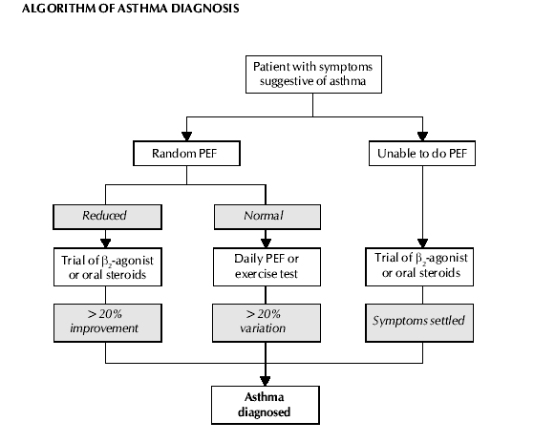

SPIROMETRY- uses

- Correct diagnosis of COPD. Fev1 is very reproducible (much better than peak flow), has well defined ranges and is a good predictor of mortality and disability (BTS COPD Guidelines 1997). PEFR underestimates airflow obstruction- is well preserved as initial ‘velocity’ of expired air is preserved even though later in expiration air trapping/ obstruction occurs.
- Diagnosis of other lung conditions- restrictive or obstructive i.e. pulmonary fibrosis (RA/Sarcoid/Farmers Lung etc), neurological weakness extra-tracheal restriction (Flow Volume Curves / loops.
- Disease monitoring. Plotting sequential FEV1’s can predict with accuracy onset of disability/ need for LTOT and even death.
- Sensitive measurement of reversibility – much better than Peak Flow.
- Gives patient useful information.
- Theoretically not very useful in diagnosis of asthma- although flow volume curves can show characteristic patterns- i.e. deep concavity in middle- F50 (point at which there is 50% of Vital Capacity left to blow) proportionally reduced, indicating medium sized airway obstruction BUT easy to do, easier to spot ‘sub maximal’ expiratory efforts and can spot COPD.

Nomograms

Not standardized- therefore should use the same one throughout the practice.

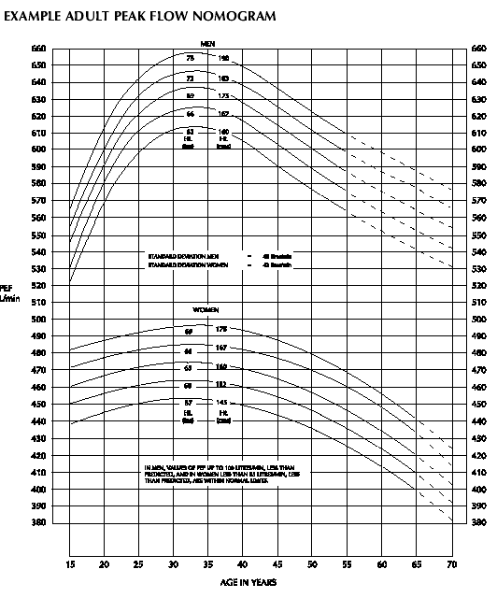

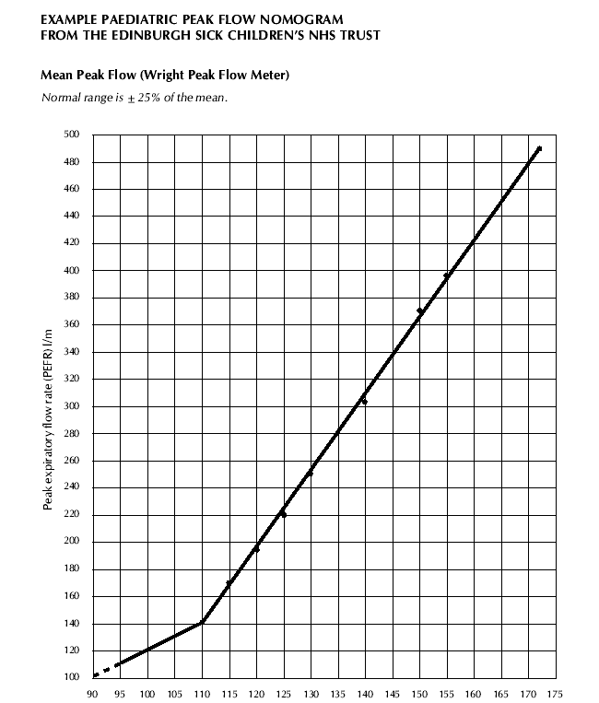

Practice Register

Need an up to date practice register of all asthma patients. Could have a subset of ‘Active’ and therefore the remaining patients would be ‘inactive’ by default.

Need a COPD register. There will be an overlap and patients could appear on both.

Use of asthma template encouraged- codes –

Asthma Formulary

Try and prescribe devices with most compatibility with spacers (steroid inhalers should ideally always be given through a spacer to minimalise oral deposition).

Aerosols are the cheapest but only 10-15% of dose is delivered to lungs despite perfect technique. Prescribe these in preference to dry powder inhalers.

Breath-actuated aerosol inhalers not as effective in young children who tend to close their glottis when valve opens. More expensive.

Dry powder inhalers have increased lung deposition- up to 30% (hence once daily dosing for example in pulmicort.

Some breath actuated dry powder inhalers need increased inspiratory rate e.g. Rotahaler needs 3 times that of turbohaler.

There is no place now for oral bronchodilators- tablets or syrup. No ‘niche’ exists for their use- in children little benefit from bronchodilators under 2 and most mums should manage a spacer and inhaler with or without a mask. A plastic cup can be useful in an emergency and less threatening than a mask.

Salbutamol cfc-free aerosol inhaler (cfc free inhalers need to be washed once a week to prevent clogging).

Salmeterol aerosol inhaler

Seretide inhaler- 50 and 100 doses combination cost effective (80% of patients controlled on seretide 50 £19:50 cf £33:32 separately. Licensed for aged 12 or over, accuhaler aged 4 or over.

Beclomethasone 50/100/250 ‘Qvar’ is an appropriate ‘Trade name’ substitution as cfc-free and double amount of drug delivery. Much more effective via spacer than fluticasone. Very cheap.

(Budesonide/Terbutaline dry powder inhalers- turbohalers.)

Fluticasone has a place in severe asthmatics, but beware increased side effects (longer drug-receptor connection) and same dose/response ceiling as other steroids.

Symbicort is a useful drug as combination of Eformoterol (less cardio toxic), works much more rapidly and has linear dose response of both components. But dry powder inhaler- needs inspiratory flow of 6l/min at least. Should be given tds. Only licensed for age >16.

Leukotriene receptor antagonists- Montelukast / Zafirlukast.

NB Budesonide has shorter half life and is really a tds drug despite recommendations (pulmicort liscensed for once daily doseing!!)- Beclometh/flutic. Better choices.

Spacers-

Volumatic best as high volume (needs to be washed reg. and allowed to drip dry to prevent static build up).

Aerochamber has increased compatibility and is far more portable.

NB anyone on higher dose of inhaled steroids i.e. >= to 800mcg beclomethasone / Budesonide or >= 400mcg fluticasone should carry a STEROID CARD. Adrenal Insufficiency is recognized as being under-diagnosed.

Initial Treatment

Management of severe Asthma. Check for the following signs-

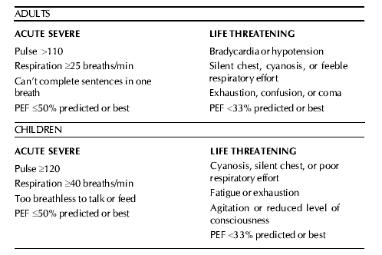

and arrange for urgent/emergency admission as appropriate.

For ‘attacks’ of asthma that are not this severe-

It is important to abolish symptoms and gain patient confidence as soon as possible- so some patients may need 2 or even 3 inhalers prescribing initially.

Always co prescribe a peak flow meter- to monitor response and a spacer if inhaled steroids prescribed.

- Beclomethasone / Budesonide 400mcg bd (can be stepped down later) or Fluticasone 200mcg bd.
- With or without a short course (1-2 weeks) of oral steroids to gain control faster.
- Salbutamol can be prescribed later.
- Review early- at 2 weeks and reduce dose in a stepwise fashion.

MAINTENANCE TREATMENT OF ASTHMA new 2002 BTS Guidelines

Step one
- Inhaled short acting bronchodilator only.

Step two
- prn use of short acting bronchodilator
- Low dose inhaled steroids twice daily

Beclomethasone/ Budesonide 100-400mcg

Fluticasone 50-200mcg

OR regular inhaled non-steroid preventer- e.g cromoglycate (good for atopic asthma in children).

Step three
- prn use of short acting bronchodilator
- Long acting Beta2 agonist plus steroids as above (FIRST CHOICE IN NEW GUIDE)
- High dose steroid inhalers via large volume spacer-

Beclomethasone / Budesonide 800-2000mcg/ day

Fluticasone 400-1000 mcg/ day

OR If high dose steroids causing side effects or there are persisting nocturnal symptoms then prescribe low dose inhaled steroids as in step two, PLUS LONG ACTING Beta-2-agonist and slow release oral theophylline. Inhaled cromoglycate or nedocromil may be tried. Leucotriene receptor antagonists also an option at this stage as add on only.

Step four
- prn use of short acting bronchodilator
- Long acting Beta-2-agonist.
- High dose inhaled steroids via a large volume spacer

Beclomethasone/Budesonide 800-2000mcg daily

Fluticasone 400-1000mcg daily

Plus one or more of the following long acting Bronchodilators may be tried on a sequential basis
- Inhaled long acting beta2 agonist
- Slow-release theophylline
- Inhaled ipratropium or oxitropium
- Long acting beta2-agonist tablets
- High dose inhaled bronchodilators
- Cromoglycate or nedocromil
- Leucotriene receptor antagonists- licensed for use in over 6’s and may have a place in mild to moderate asthma. No effect in acute asthma attacks. No evidence that using these will allow a reduction in inhaled corticosteroid doses.

Step Five
- prn use of short acting bronchodilator
- High dose steroid inhalers via large volume spacer-

Beclomethasone / Budesonide 800-2000mcg/ day

Fluticasone 400-1000 mcg/ day

AND one or more long acting bronchodilators as in step 4

AND regular oral prednisolone taken as a single daily dose.

TREATMENT OF CHRONIC ASTHMA IN CHILDREN UNDER FIVE

Step One
- Occasional prn use of beta 2 agonist- INHALED. No place for syrups!!
- If use more than once daily step up!

Step Two
- Occasional prn use of beta 2 agonist- INHALED.
- Low dose steroid inhalers daily- Beclomethasone / Budesonide <= 400mcg Fluticasone <= 200mcg

After 4-6 weeks assess response and either STEP DOWN if well controlled or gain control by-

- 5 day course of pred-sol (< 1 year 1-2mg/kg/day, 1-5 years 20mg/day and DOUBLE DOSE OF INHALED STEROID TEMPORARILY – 2-3 DAYS.

Step Three
- Long acting Beta-2-agonist twice daily
- ADD High dose steroid inhalers via large volume spacer

Beclomethasone / Budesonide 800mcg/day

Fluticasone 400mcg/day
- Consider short course of predsol, Leukotriene receptor antagonists or oral theophylline – especially effective at night but causes noticeable side effects in 1 in 3 children.

Step Four
- Occasional prn use of beta 2 agonist- INHALED
- Long acting Beta-2-agonist twice daily
- Inhaled steroids <= 2mg daily
- And as above- short rescue courses, oral theophylline, leukotriene R antag’s.

IMPORTANT TO REVIEW REGULARLY- 2-4 TIMES A YEAR AND STEP DOWN AT EVERY OPPORTUNITY. This group needs regular weight and height measurement. Inhaled steroids can be reduced by 25-50% every 1-3 months.

Management of Chronic Asthma in Children under Two

Be sure of diagnosis! Remember it is being over-diagnosed in this group. Best symptom for prediction is wheeze. Atopy and Fhx are more important. 40% of eczematics have asthma too. Without atopy or fhx asthma unlikely and should be referred.

Acute exacerbations-
- Inhaled beta-2-agonist 1 puff every 30 seconds for 10 puffs via spacer
- Repeat at 3-4 hours.
- If after 12 hours still symptomatic give predsol for 1-3 days in doses as above
- If severe asthma and poor inspire. Flow- nebuliser.
- O2 saturation monitoring useful in this group- <92% ADMIT!

Review and Follow-up in Chronic Asthma Management

- Every time review symptoms, peak flow record and technique.
- Assess patients understanding.
- Aim to establish a self management plan- either based on symptoms (see appendix) or peak flow.

Symptoms of Good Control

- No Daytime Symptoms
- No Night time symptoms
- Normal level of physical activity
- No exacerbations
- No absenteeism
- No need for prn beta-2-agonist
- Normal Fev1, Fev1/FVC
- Normal PEFR
- Less than 10% diurnal peak flow variability

Symptoms of Acceptable Control

- Day-time symptoms < 3days/week
- Night-time symptoms < 1 night/week
- Normal level of physical activity
- Mild infrequent exacerbations
- No absenteeism
- <3 doses of prn beta-2-agonist a week
- Fev1, Fev1/FVC 90% personal best
- Less than 15% diurnal variation 5 days/week

Start Chronic Disease Treatment at level appropriate for severity.

Step 1- Daytime symptoms- once a day, night-time twice a month, no limitation in exercise and< once a day use prn beta-2-agonist. Highest reading of peak flow over 2 weeks >/= 80% of predicted. Peak flow variability <20%.

Step 2- Day time symptoms once a week to less than daily. Night time symptoms twice a month to once a week. Occ. Limitation of exercise. Highest peak flow >/= 80% of predicted. Peak flow variability 20-30%.

Step 3- Daytime symptoms daily not continuous. Nocturnal symptoms once a week to < every night. Prn Beta-2-agonist once a day. Highest peak flow reading over 2 weeks 60-80% of predicted. Peak flow variability >30%. (ALSO START ON THIS STEP WITH COURSE OF ORAL STEROID).

Step 4- Continuous daytime symptoms, frequent or every night nocturnal symptoms, Continuous limitation of activity, Beta-2-agonist more than daily, Highest peak flow </= 60% predicted, peak flow variability >30%. (ALSO START ON THIS STEP WITH COURSE OF ORAL STEROID).

Review everyone at 2 weeks initially. Then:-

Step One review at 3 months then yearly.

Step Two review at 6 weeks then 3 months then 6 monthly

Step Three review at 3 weeks then 6 weeks then 3 monthly

Step Four review every 2 weeks until stable then 3 monthly. Outpatient referral?

Step Five arrange for consultant review at earliest opportunity.

Step down at earliest opportunity.

Written Management plans for everyone.

Ensure Pneumococcal and Influenza Vaccines been given (see separate guidelines).

CRITERIA FOR REVIEW BY GP.
- Difficult cases
- Where diagnosis is in doubt
- Patients on steps four or five
- Patients requiring several courses of oral steroid annually
- Long term Smokers (COPD or dual-diagnosis?)
- Co-existing atopic illnesses (e.g. asthma triggered by severe hay fever every year)

CRITERIA FOR SPECIALIST REFERRAL.

- On Steps four or Five of Treatment ladder.
- Brittle Asthmatic or poorly responsive to treatment.
- Children on continually high doses of inhaled steroids.
- Where diagnosis is in doubt.
- Evidence of eosinophilia, infiltrations on CXR and no response to leukotrienes (Churg Strauss).

